Computer configuration and Software installation



MY COMPUTER SPECIFICATIONS

1-To check my ram: free -h
It means I have a total memory of 14 GB and 6.9 GB is free. The RAM is the memory used by the computer to perform operations, and it’s sufficient for this project.
2-To see the GPU: lspci | grep -i vga
It means the GPU is an AMD/ATI Barcelo (Radeon integrated).
3- To see my ubuntu version: lsb_release -a

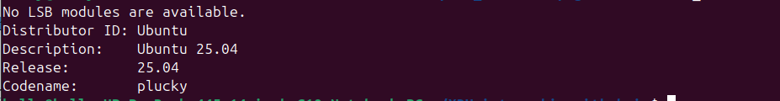
This Ubuntu version is too recent for ROS Noetic used for this project. ROS Noetic need Ubuntu 24.

4-To check the disk space: df -h /
The disk allow us to stock 26 GB of information.

Summary of my computer specifications :

OS | Ubuntu 25.04 | Too recent
RAM | 14 GB | Perfect
GPU | AMD Barcela | CPU mode only
Disk | 26 GB free | Enough
Drive | NVMe SSD | Very fast

The problem with computer characteristics

1-My GPU is CPU only
My computer only has a CPU, which means it can perform one operation at a time, and that is a problem for using Machine Learning for crop recognition. GPUs allow for several operations to be done in parallel, which is why they are useful for Machine Learning.

But the car we want to use is the LIMO PRO, which has the following characteristics:
Processor | NVIDIA Orin Nano
GPU cores | 1024 CUDA cores
AI power | 40 TOPS
RAM | 8 GB LPDDR5
Storage | 64 GB eMMC
Solution :
My own computer can’t be used for YOLOv5s training because of its lack of a GPU, but I can do the YOLOv5s training directly on the LIMO according to its characteristics.

2-My Ubuntu version is too recent for ROS
Indeed, we need Ubuntu 20.04 for ROS1.

Solution:
We will use Docker and work on it. We can directly work on the LIMO, but we choose to work on Docker to enable us to continue working outside the Lab.

Languages and Software installation

1-Python:
We will use OpenCV, YOLOv5s, and ROS for the project, and each one of them needs:
- OpenCV needs: Python 3.13
- YOLOv5s needs: Python 3.11
- ROS needs: Python 3.8

Python version on computer:
Unfortunately, this version only matches with OpenCV.
Solution:
We will install Python 3.11 for YOLOv5s and for ROS we don’t need because Python 3.8 Noetic is in Docker.
Python 3.11 installation: Sudo apt install -y python3.11 python3.11-venv python3.11-dev

error during installation:
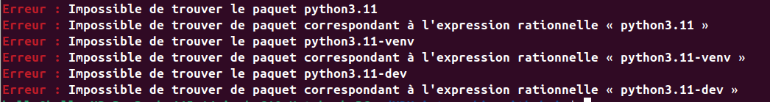
This problem come from the absence of Python 3.11 in the default repository of Ubuntu 25.04 I have, so to continue the installation we need to add it.

Installation by building Python 3.11 from source
This is the most reliable method. Run each command one by one:
1-Remove the broken deadsnakes repository
sudo add-apt-repository --remove ppa:deadsnakes/ppa
sudo apt update
2- Install buil dependencies
sudo apt install -y build-essential zlib1g-dev \
libncurses5-dev libgdbm-dev libnss3-dev \
libssl-dev libsqlite3-dev libreadline-dev \
libffi-dev curl libbz2-dev

3- Download Python 3.11 source code
cd /tmp
curl -O https://www.python.org/ftp/python/3.11.9/Python-3.11.9.tgz
4- Extract the source code
tar -xzf Python-3.11.9.tgz
cd Python-3.11.9
5- Configuration of the build
./configure –enable-optimizations
6- Compilation of Python 3.11
make -j$(nproc)
7- Installation of Python 3.11
sudo make altinstall
8- Verification of the installation
python3.11 –version
Result:

9- Installation of pip for Python 3.11
curl -sS https://bootstrap.pypa.io/get-pip.py | python3.11

10-Verification of the pip
python3.11 -m pip --version
Result :

The Virtual environment of work(robot_project)
Since OpenCv as its own Python version, to avoid a conflict of Python with my original computer Python version I created a virtual environment for executing the OpenCV code.

# ENTER the environment
source ~/robot_project/bin/activate
→ (robot_project) appears

# EXIT the environment
deactivate
→ (robot_project) disappears

# Re-enter anytime
source ~/robot_project/bin/activate
→ (robot_project) appears again

VS CODE EXTENSION

code --install-extension ms-python.python && \: python extension
code --install-extension ms-vscode-remote.remote-ssh && \ : remote ssh, for accessing LIMO PRO from VS Code.
code --install-extension ms-iot.vscode-ros && \ : To write ROS Code properly.
code --install-extension ms-azuretools.vscode-docker :

DOCKER
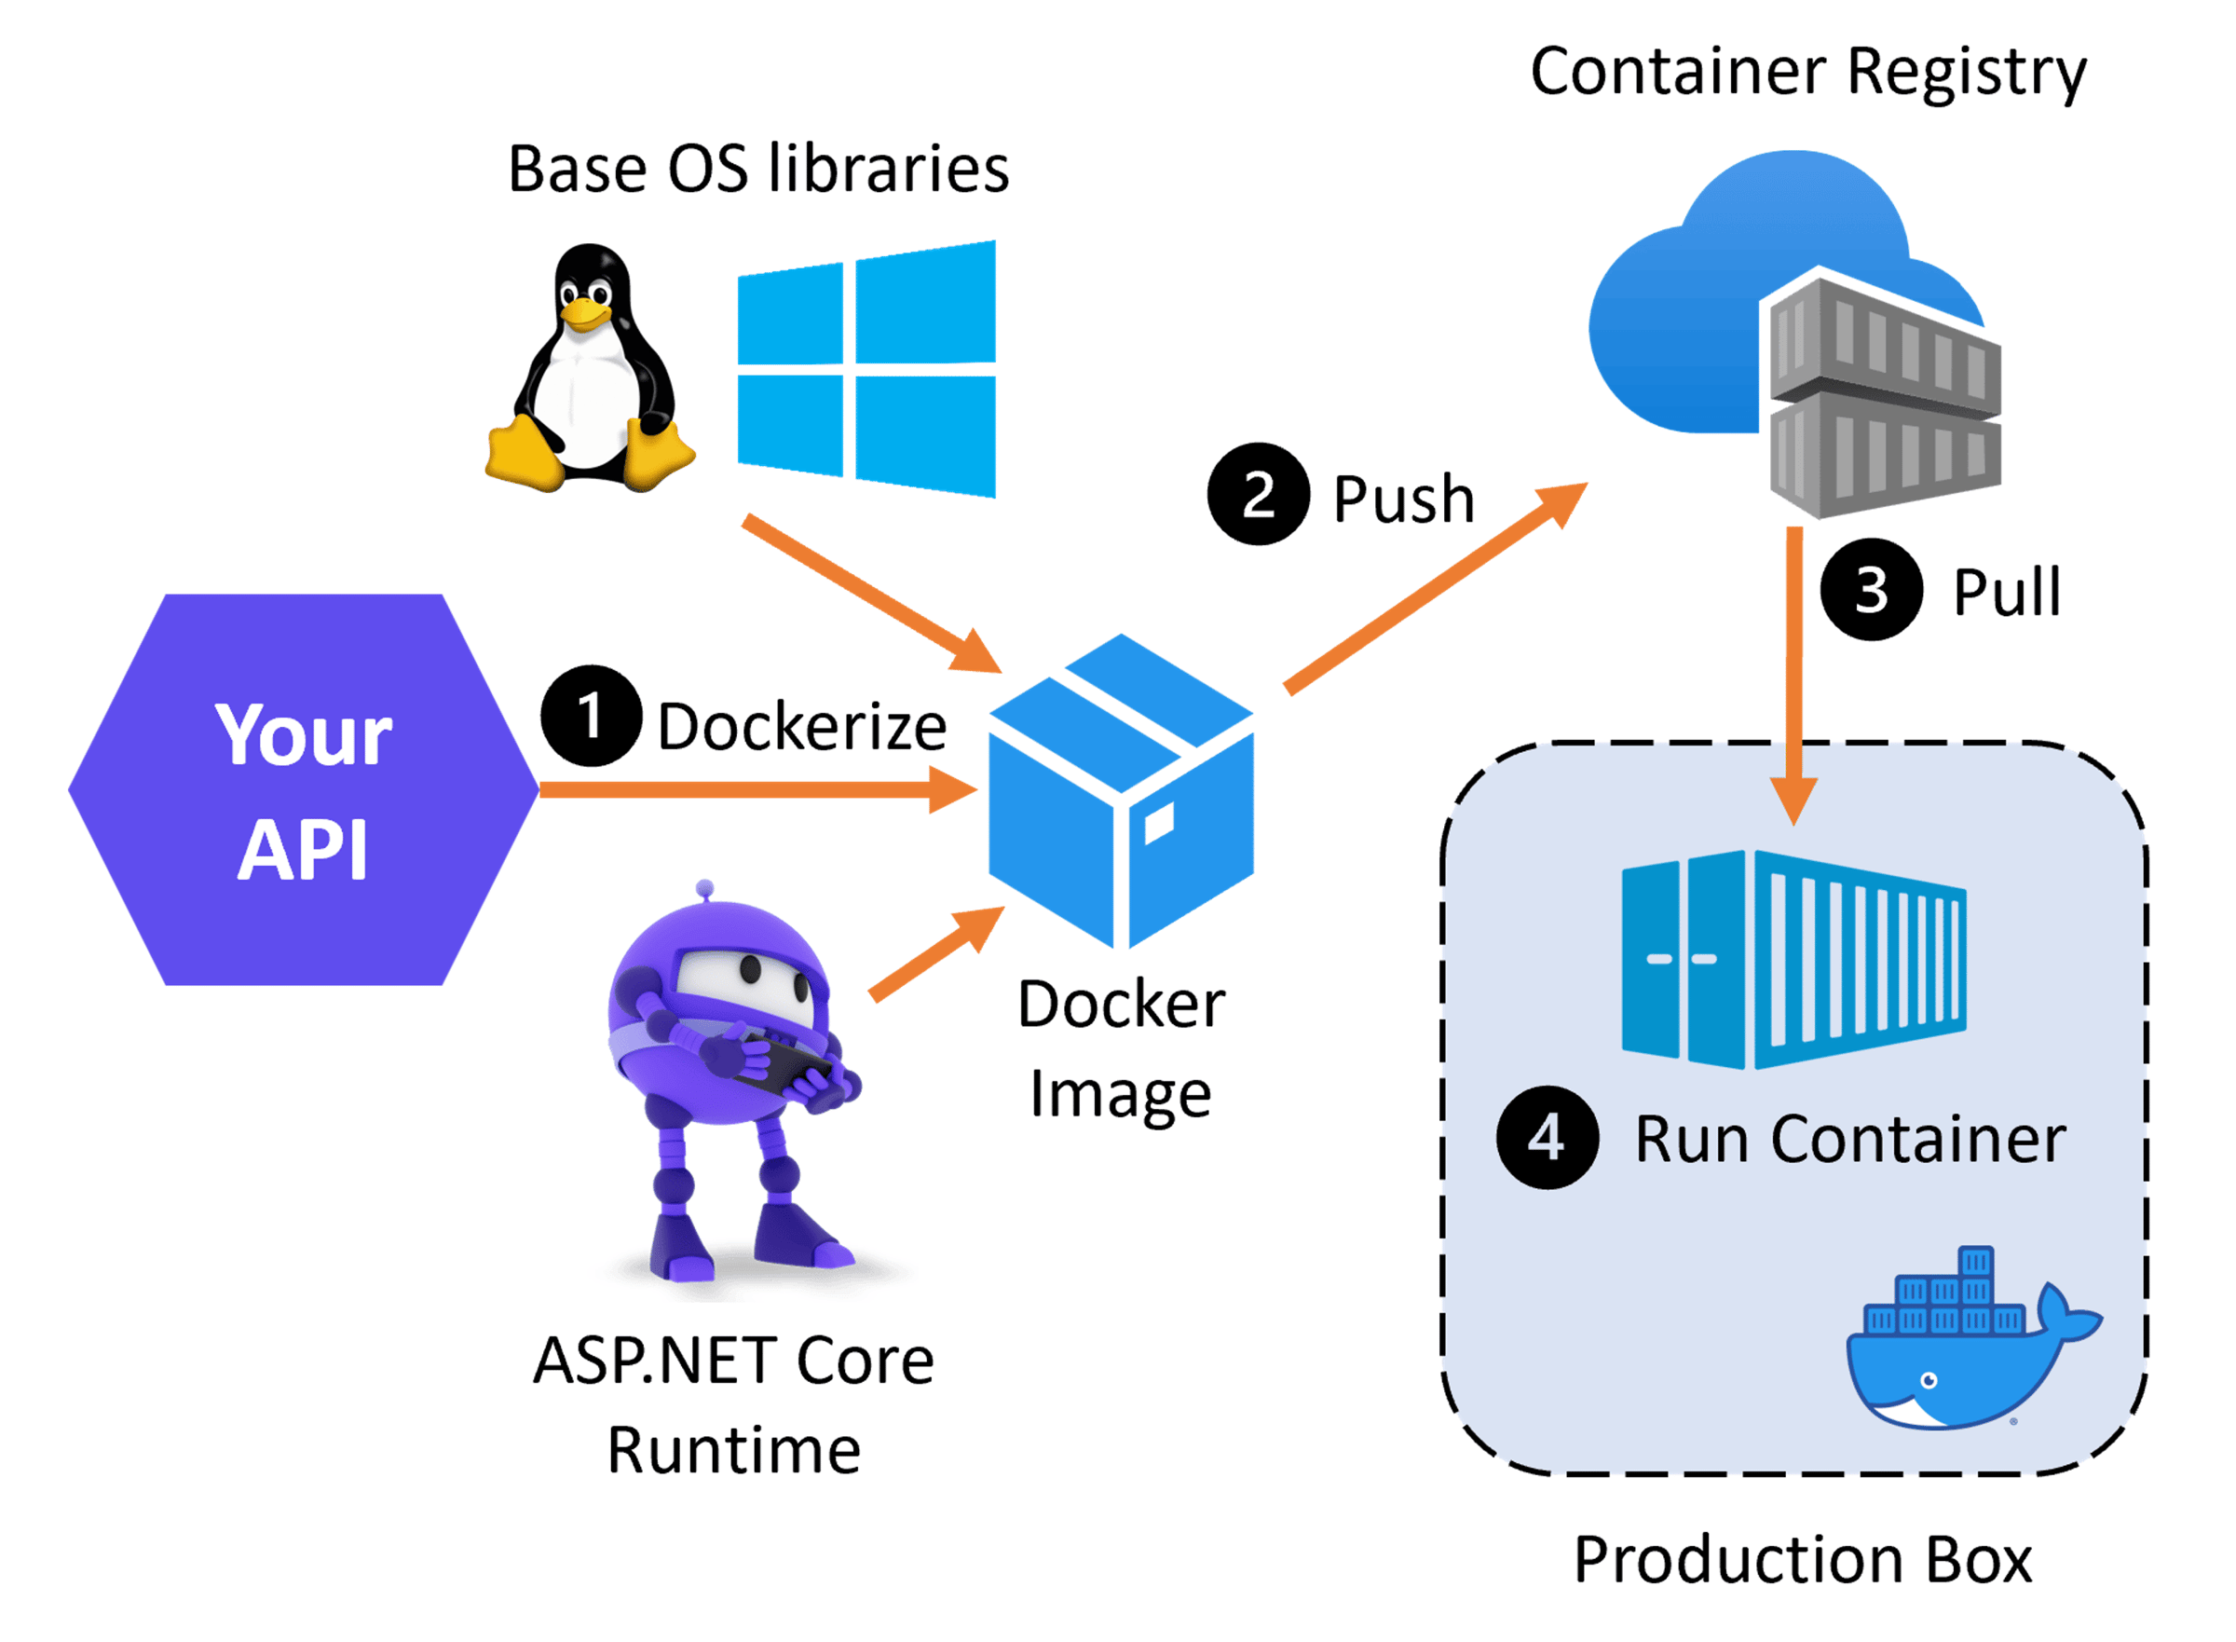

Since my computer runs ubuntu 25, which isn’t compatible with ROS, we chose to run ROS in a Docker container.

Docker installation:

Once Docker is installed, we must restart the computer. If we don’t want to restart the computer, we must inform the computer the use Docker by entering “newgrp docker” in the terminal.

The first thing we must do every time we turn on my computer is to launch all the container. We do it with the following command:
- docker start -ai ros_kelly

Steps to use ROS on Docker
We need at least three terminals, and to configure them we follow the following commands:

Terminal 1: The master (the bain)
This terminal manages the phonebook so the two other terminals can find each other.
1- Enter the container: docker exec -it ros_kelly bash
2- Sourcing ROS: source /opt/ros/noetic/setup.bash
3- Turn on ROS tools or start the heart: roscore

Terminal 2: The listener (the subscriber)
This terminal represents the robot logic (like a robot arm waiting for a command).
1- enter the container: docker exec -it ros_kelly bash
2- Sourcing ROS: source /opt/ros/noetic/setup.bash
3- Listening to the channel: rostopic echo /chatter

Now, the Terminal 2 is waiting for a command coming from the Terminal 3.

Terminal 3: the talker (the publisher)
This terminal represents the sensors (like the LIMO PRO camera or LiDAR).
1- Enter the container: docker exec -it ros_kelly bash
2- Sourcing ROS: source /opt/ros/noetic/setup.bash
3- Send a message: rostopic pub -r 1 /chatter std_msgs/String "data: 'LIMO robot is ready'"

Once we enter the command 3, the message ‘LIMO robot is ready’ will be displayed in the 2nd terminal.

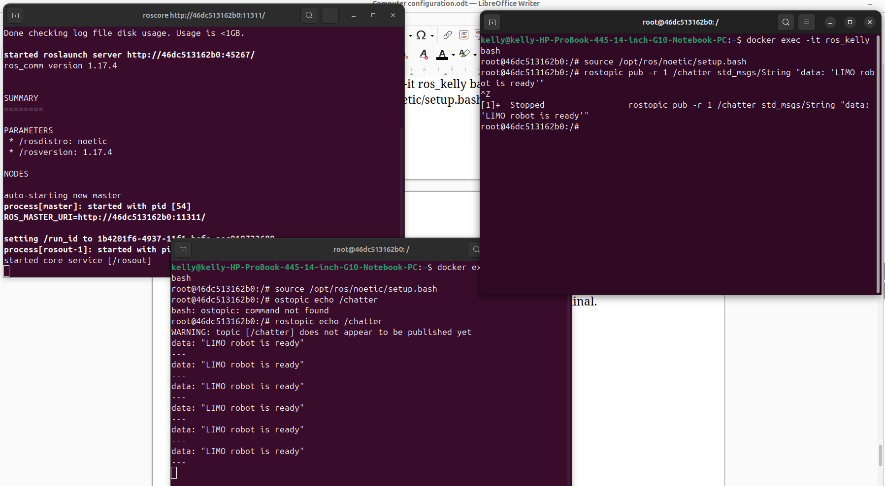
Terminal 1 : the master
Terminal 3 : the talker
Terminal 2 : the listener

